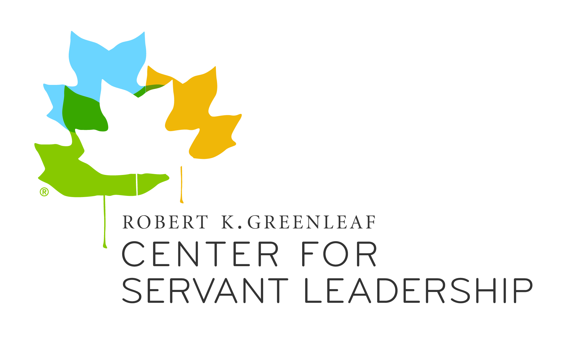

Greenleaf Center for Servant Leadership
Greenleaf Scholars Award 2017
To Advance Research on Servant Leadership

Program: The Greenleaf Center for Servant Leadership is sponsoring awards for pre-tenured faculty, early career practitioners, and advanced graduate students in any discipline who engage in research that explores servant leadership. Applications from outside of the United States are welcome; all application materials and final research by those chosen as Greenleaf Scholars must be completed in English. The National Forum on Higher Education for the Public Good at the University of Michigan will administer the program. Award selections will be made with an international steering committee comprised of representatives from:

University of Michigan
University of Detroit Mercy
Georgia Institute of Technology
VU University Amsterdam
Gonzaga University
University of Notre Dame
University of Illinois at Chicago
State University of New York at Buffalo

Methodology: The international review committee of the Greenleaf Scholars Program affirms excellence in the human sciences across a plethora of methodologies available to contemporary researchers. The committee will consider quantitative and qualitative proposals of high merit separately, and invites early career scholars to send their best work for consideration. In light of the overall goals of the program, should proposals in each category be deemed of high merit, both quantitative and qualitative studies will be funded.
Award: The award of $2,500 will be made to individuals in order to support outstanding research and encourage publication. Additionally, award recipients will receive support for the following:
- Conference registration fees waived and travel stipend provided to attend the Greenleaf Center for Servant Leadership International Conference upon completion of research.
- Possible support for travel to other conferences or opportunities related to servant-leadership.
- Possible inclusion of the manuscript from their project in an edited book on servant leadership and encouragement to publish the research in peer-reviewed journals.
Qualifications: All recipients should hold a doctorate (no more than five years post-degree) or be at the dissertation stage of their doctoral studies (i.e., candidacy).
Deadline: All application materials must be received by the National Forum by Friday, March 17, 2017.
Award inquires may be sent to: greenleafscholars@umich.edu.
Greenleaf Scholars Program 2017
To Advance Research on Servant Leadership

APPLICATION – FORM A
Please submit all materials and final product in English

Please type responses into the grayed spaces and save as a PDF or Word document (submission instructions appear at the end of the application):
Section 1: Personal information
Name:
Last |  |  |  |  |  |  | First |  |  |  |  | MI
Contact information:
Mailing Address |  |  |  |  |  |  |  | Postsecondary Institution
Street |  |  |  |  |  |  |  | Street
City |  |  |  |  |  |  |  | City
State |  |  |  | ZIP |  |  |  | State |  | ZIP
Telephone |  | ( ) - |  |  |  |  |  | Telephone | ( ) -
Fax |  | ( ) - |  |  |  |  |  | Fax | ( ) -
E-mail address
Section 2: If you already have your doctorate, please complete this section. If not, proceed to Section 3.
Current Institutional Affiliation:
Department / Institution
Present Position or Title
Date of Doctoral Conferral
Institution of Doctoral Conferral

Section 3: If you are a doctoral student or candidate, please complete this section:
Institution
Discipline
Expected Date of Doctoral Conferral
Dissertation Topic
Contact information and signature from advisor or dissertation committee chairperson is required of doctoral candidates only (see Form B).
Advisor Name / Committee Chair
Telephone Number

Section 4: (Optional) What is your race/ethnicity? (We use this to analyze the demographics of our applicants.)
Native American or Alaskan Native
Asian
Native Hawaiian or Pacific Islander
Latino/a or Hispanic
Mexican American / Chicano
African American or Black
White
Other:

Greenleaf Scholars Program 2017
To Advance Research on Servant Leadership

APPLICATION - FORM B
Name
Last |  | First |  | MI

- Please write a description of the research (1800 word maximum) that you are proposing to support with this award. It is recommended that you address the following topics in your proposal statement:
- Abstract (50-100 words) of proposed project
- Significance of work to the servant-leadership movement
- Research topic
  - What is the importance of your research?
  - How are you operationalizing your dependent and independent variables?
  - Do you have access to data currently?
    - Which dataset do you propose using? Do you have a plan to get data?
- Relevant theoretical framework
- Relationship of work to relevant literature
  - How does your topic contribute to the work on servant-leadership?
  - What gap in the literature does your research address?
- Description of methodology
  - What empirical methods will you apply?
  - Have you completed ethical treatment of human subjects paperwork?

- On a separate page in no more than 500 words, please describe your plans for your research proposal. What kind of impact do you expect your research to make? Do you plan to submit to journals or conferences? If so, please name the journals or conferences you have identified. Additionally, have you previously published or presented about research related to servant-leadership? Please give the name of the article/journal/conference.

- On a separate page in no more than 600 words please include a concise definition of the concept of servant-leadership and explain how this definition connects to your proposed research. Please describe how your research builds upon the foundations of Robert K. Greenleaf’s works.

- Please attach a biographical sketch of no more than one page.

- Important Application Instructions – Please submit your research proposal, your description of plans, and the definition of servant-leadership as one PDF document with NO personally identifiable information. Please submit the application and biographical sketch in a separate document.

Statement of Certification
I hereby certify that the information in this application package is complete and accurate. I recognize that the information in this application becomes the property of the Greenleaf Center to be used in connection with their work on servant-leadership. Any work from my application will be ascribed to me. I understand that misrepresentation of any portion of this application may be cause for cancellation of this award. I also understand that this award includes participation in an International Conference of the Greenleaf Center. The Greenleaf Center will provide a stipend to defray travel and local costs for the conference at which my research results are presented. I will provide the Greenleaf Center with an annual statement of progress, until I submit my completed project. In addition, I expect to submit a completed manuscript from the proposed research by December 15, 2017. There may be other scholarly opportunities available during the period of the award.

Signatures: |  | Date
Applicant |  |  | / /2017
Advisor/Chair  (Ph.D. candidates only) |  |  | / /2017
Greenleaf Scholars Award 2017
To Advance Research on Servant Leadership

CHECKLIST

Completion Checklist:
- Application
Please send all materials to greenleafscholars@umich.edu
as e-mail attachments.
- Description of proposed research
- Definition of servant-leadership
- Biographical sketch
- Signed Form B
If you are unable to email please mail materials to:
National Forum on Higher Education for the Public Good
University of Michigan
SEB 2339 C/O Greenleaf Scholars Program
610 E. University Ave
Ann Arbor, MI
48109-1259

